Go to https://www.techsmith.com/snagit.html and download free version first. After using for 2 weeks, if you will keep using email me to get a key to activate your free trial (don’t use the buy now link).
Snag-It Features
Screen capture will allow full/partial screen, panoramic, and scrolling. It also allows you to add annotations and editing features/effects.
Video capture records the action on the screen and audio (from a microphone or system audio) as a MPEG-4 video file. It can also incorporate the use of the webcam. Use Snagit videos to:
- Record a demonstration or how-to video.
- Walk someone through a process or issue/Provide enhanced feedback. Give audio feedback while recording a video stepping through the content on the screen.
- Record a PowerPoint Presentation
- Record videos from web (youtube or other) for use in class
  - Especially good for videos that may be moved or removed and to address issues with school firewall systems
- Strengths: Affordable, quick, easy learning curve. Weaknesses: Not good if you need more than basic cut editing capabilities.
Detailed tutorials for Snag-It can be found at https://www.techsmith.com/tutorial-snagit-13.html
Two Ways to Launch the Snag-It Capture Window:
- Launching the Snag-It Capture Window from the notification area (this gives you options and the ability to set defaults and presets)
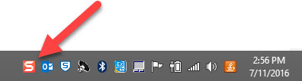 | 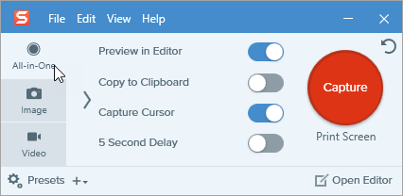

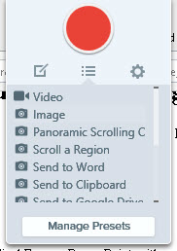
- Using the pull down Snag-It window
Once Snag-It is running (I set it to auto load) go to top of your screen and “swipe down”. You can manage the pre-sets to include the options you use most frequently and can create your own presets!

Quick steps images:
- Launch Snag-It (Start window or quick link) unless it is set to auto start.
- Launch capture window and choose appropriate capture type (image, scroll a region, and panoramic scrolling would be most common)
- Once Snag-it editing window is open you can add annotations and other effects and then save the file (JPEG format is best format for sharing). Use File, Save As or use
Quick steps Video:
- Prepare for video. Make sure all windows you need are open, all advertisements have already played (have video ready and paused)
- Launch Snag-It (Start window or quick link) unless it is set to auto start. Set your video preferences using File, Capture Preferences from Capture window OR Settings, Capture Preferences from pull-down menu. Make note of your hot keys.
- Launch capture window and choose appropriate capture settings (can use pull down snag-it window for pre-set settings). F1 will bring up menu choices for capture (generally click and drag region or click F for full screen)
- Know your recording toolbar
Finish Recording (blue) and Record (red) | Pause | Record live video webcam | System Audio  Microphone Audio | Timer | Restart | Close | Minimize Window

If you do not see recording toolbar – bring it up from the notification area (if you minimize you can bring up from notification setting)
- Make sure you check your audio settings!
- Note Webcam will record live video of the connected or built-in webcam. Screen video is not recorded when the webcam option is enabled (so it is a toggle setting). Use the webcam when you don’t have relevant screen content or to emphasize a point. The microphone is separate from the Webcam (don’t forget to turn on microphone or you will be a mute talking head!)
- When you finish, editor will open automatically. Remove (cut) sections as needed (dead air at end, cell phone interruptions in middle). Use scroll bar to set start/end points and choose cut.
- File, Save As MP4 file. You can also use “Share” for more options including drop-box, YouTube, GoogleDrive, and more.

